*Synapse Quantification (SynQuant)*

Introduction

SynQuant is a Fiji plugin that automatically quantify synapses from multi-channel fluorescence microscopy images. Both synapse and corresponding dendrite are detected. Synapses are detected on synapse channel, where they act as puncta surrounded by highly inhomogeneous interference signals. Dendrite is extracted from the reference dendrite channel.

SynQuant detect synapses through a totally unsupervised probability principled framework. In this framework, analysis is conducted on salient regions rather than pixels. All synapse candidates are scored by their own local contrast and compared fairly with each other. What’s more, false discover rate (FDR) control is utilized to determine synapse selection, which not only controls the false positive rate but also provides a statistical evidence of the detected synapse. The parameter used in this framework is only the value of FDR which is easy to tune. SynQuant extract dendrite by steerable filter [1]. Extracted dendrite then are segmented into roughly homogeneous pieces by branch points and end points. Based on the dendrite pieces and synapses, linear regression is used to find the effects of dendrite’s properties to the number of synapses on it.

How to cite

The journal paper for this algorithm is in preparation. You can cite the conference paper first:

Yizhi Wang, Guilai Shi, Yinxue Wang, Lin Tian, Guoqiang Yu*, “PPSD: Probability Principled Synapse Detection,” BioImage Informatics Conference 2015, October 2015.

Tutorial

***Installation***

Download file “SynQuant_-1.0.jar” from “https://github.com/VTcbil/SynQuant”. To install the SynQuant plugin, simply save the jar file to the folder “\Fiji.app\plugins\” and call “Help=>Refresh Menus” or restart Fiji/ImageJ. The SynQuant plugin will be available in Fiji/ImageJ’s “Plugins” menu.

Some functions of SynQuant plugin are based on Apache Commons Math, which is supported by latest Fiji version (1.50d). Also you can download the “commons-math*-*-bin.zip” from “address” and save the “commons-math*-*.jar” to the same file as “SynQuant_.jar”.

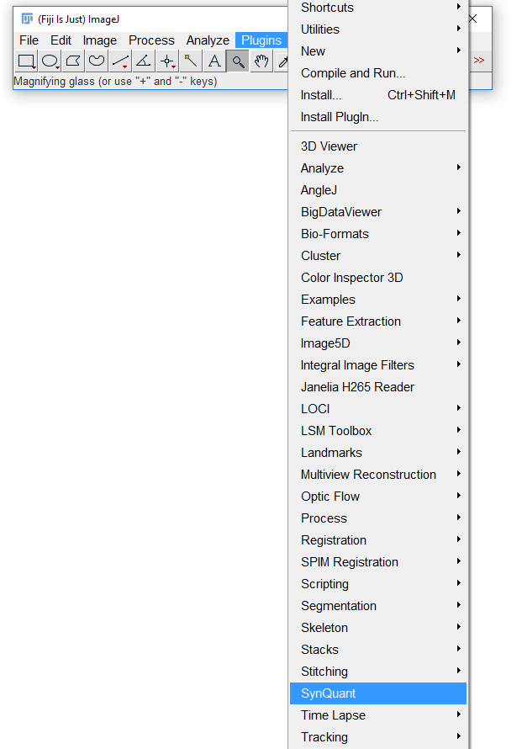

The plugin has been tested and successfully run on ImageJ version 1.50d. If users encounter problems using older version of ImageJ, please update your ImageJ to the newer version.

***Input***

SynQuant is designed to handle 8-bit or 16-bit grayscale image. User can use Fiji/ImageJ’s “Image\Type\8-bit (or 16-bit)” to first change the data into these formats and then call SynQuant. If the image contains multiple channels, user need to verify the synapse channel for synapse detection and dendrite channel for dendrite extraction. It also could handle single channel 8-bit or 16-bit grayscale image for one of the two tasks.

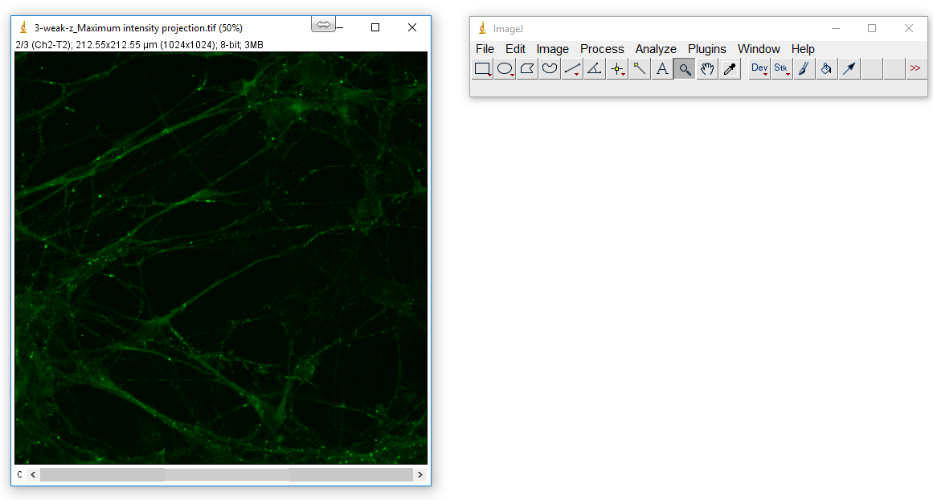

***Parameter setting***

With the grayscale image, run SynQuant from the Plugins menu. A dialogue will show and ask user to input parameters. The first two are to specify synapse and dendrite channel. If only want to do synapse detection or dendrite extraction, input the corresponding channel number and set the other zero. The third is the threshold for FDR Control. Suggested value is given as default in the textboxes. After setting the parameter, click “OK”. The running time is decided by the image size. A 1024*1024 image typically takes 6 minute on Intel Xeon CPU E5-2630 for both synapse detection and dendrite extraction.

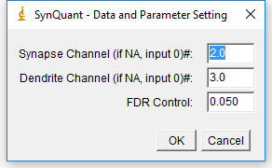

***Outputs***

The results are given in two colorful output images. One is the combination of detected synapse and original synapse channel (left). All detected synapses are marked as orange. The other one is combination of extracted dendrite and original dendrite channel (right). All extracted dendrite is marked as white. User can use “File\save” to save the outputs.

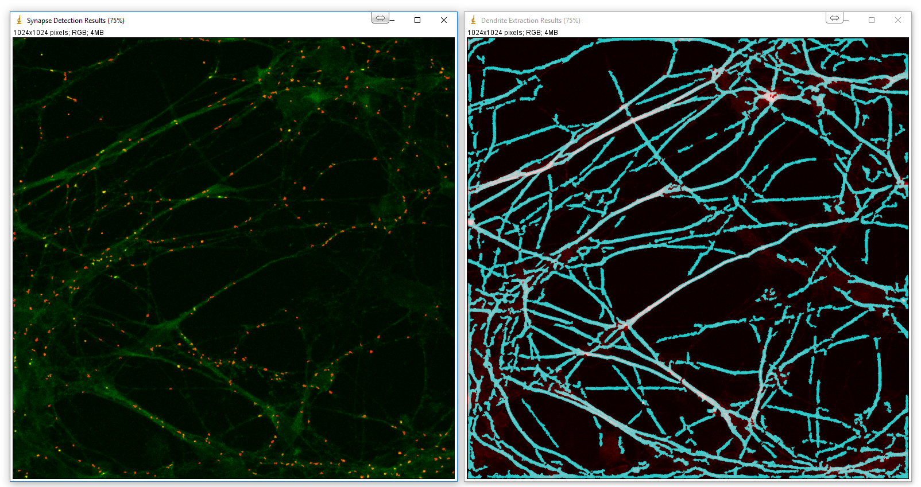

The features are given in feature table. It provides features of each dendrite piece including length, scale, intensity and number of synapses grow on it.

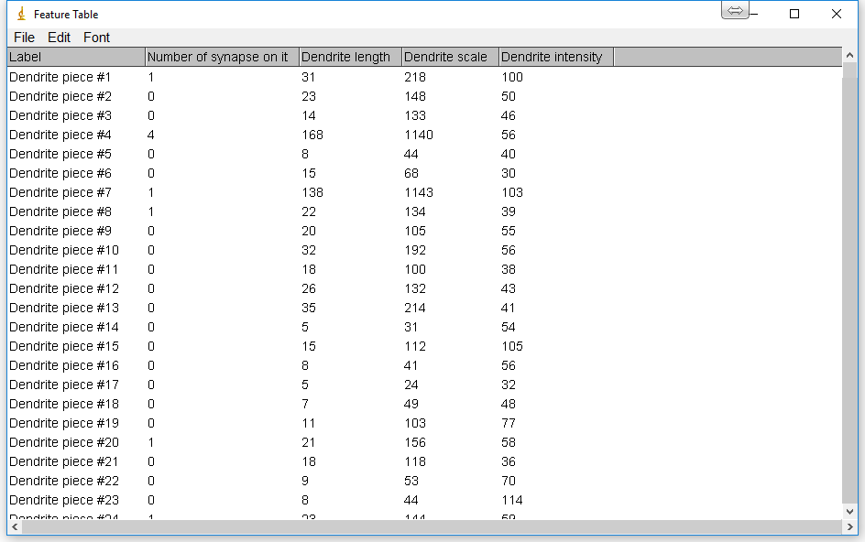

The effects of the former three dendrite features to the number of synapses grow on it are given in the summary table. The values are the corresponding coefficients got from Poisson regression.

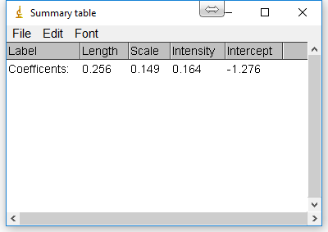

If you have any question, please contact [ccwang@vt.edu](mailto:ccwang@vt.edu).

1. Meijering E, Jacob M, Sarria J, Steiner P, Hirling H, Unser M. Design and valida-tion of a tool for neurite tracing and analysis in fluorescence microscopy im-ages. Cytometry A 2004;58:167–76.